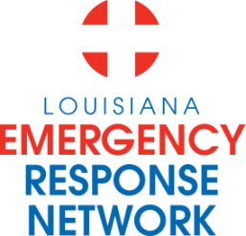

Louisiana Emergency Response Network
Board Meeting
January 24, 2013
2:00pm – 4:00pm
Location: Louisiana Emergency Response Network - Headquarters
14141 Airline Hwy, Suite One, Suite B Baton Rouge, LA 70817

AGENDA
1. Welcome and Introduction of New and Current LERN Board Members
2. Roll Call and Establish a Quorum
3. Approval of Agenda
4. Approval of Minutes of August 17th – 18th, 2012 & October 24, 2012 Board Meeting
5. LERN Business:
- Executive Director Report P. Hargrove
b. Ratification of Commission/Board Members P. Hargrove
c. EMS Data and Participation Agreement, BAA & P. Hargrove
Data Use Agreement
d. Trauma and EMS Registry Data Request Policy/ P. Hargrove
Research Review Committee
e. Communication Center CY 2012 Report C. Hector
f. Region 9 issue P. Hargrove
g. Budget/Finance P. Sullivan/C. Barr
h. Contract Breazele, Sache, & Wilson P. Hargrove i. LERN Medical Director Report R. Coscia, MD
j. Chairman’s Closing Remarks N. McSwain, MD

6. Public Comment
7. Adjournment

NEXT BOARD MEETING DATE - March 21, 2013
2 -4 p.m. LERN Office, Baton Rouge La

